Name: Sandesh Varma                                                                 Date: 01/08/2025

Roll No: CH.EN.U4CSE22078

Experiment No: 4

__________________________________________________________________

Aim: To write a program in YACC for parser generation.

Algorithm:

1. Get the input from the user and Parse it token by token.

2. First identify the valid inputs that can be given for a program.

3. Define the precedence and the associativity of various operators like +,-,/,* etc.

4. Write codes for saving the answer into memory and displaying the result on the screen.

5. Write codes for performing various arithmetic operations.

6. Display the possible Error message that can be associated with this calculation.

7. Display the output on the screen else display the error message on the screen

Code:

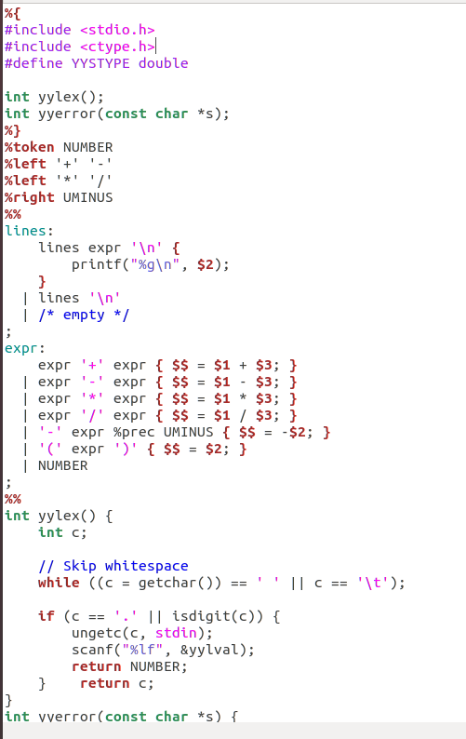

Sandesh Varma

CH.EN.U4CSE22078

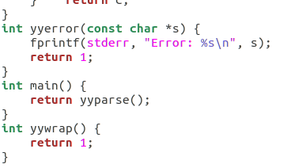

Output:

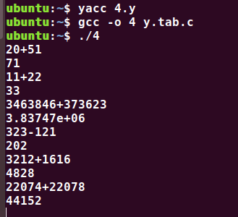

Results: The program in YACC for parser generation has been executed successfully